Asia-China-Coin-9-Wang Mang-H9.13 attached

FD 455

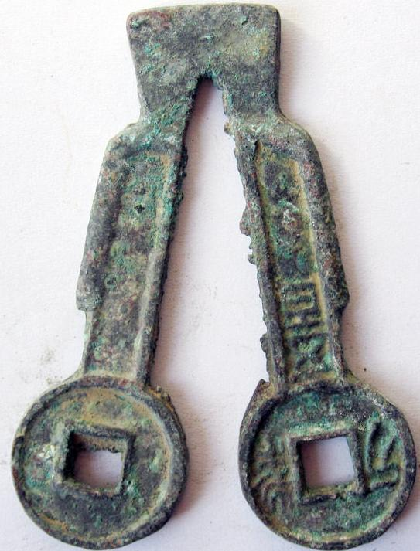

INCLUDEPICTURE "../../../Local%20Settings/Temp/scl15.jpg" \* MERGEFORMATINET 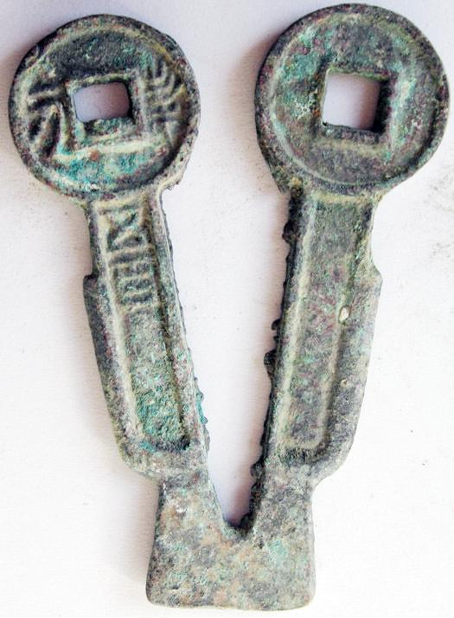 SHAPE \* MERGEFORMAT 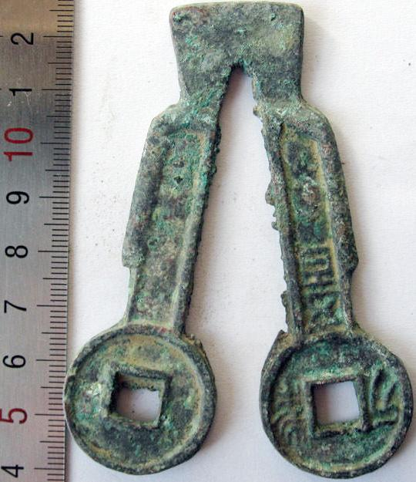

[SHAPE \* MERGEFORMAT 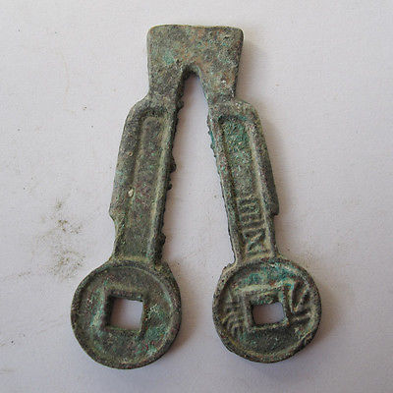](http://www.ebay.com/itm/380806595186)

[Warring States spade the original coin 041823](http://www.ebay.com/itm/380806595186)

Item price

$19.88

Quantity

1

Item number

380806595186

Shipping service

Economy Shipping from outside US

[Leave feedback](http://feedback.ebay.com/ws/eBayISAPI.dll?LeaveFeedbackShow&useridfrom=802-867&useridto=linzhoulin&item=380806595186&transactid=0) [Contact seller](http://contact.ebay.com/ws/eBayISAPI.dll?FindAnswers&frm=3998&iid=380806595186&redirect=0&requested=linzhoulin) [Return item](http://return.ebay.com/ws/eBayISAPI.dll?ResolveReturn&eventName=viewSelectedItem&TransactionId=0&ItemId=380806595186)